Spatial Decision Support System for
MP Jal Nigam
User Manual




M.P. STATE ELECTRONICS DEVELOPMENT CORPORATION LTD.
State IT Centre, 47-A, Arera Hills, Bhopal-462011 (M.P.)
www.mpsedc.mp.gov.in
Table of Contents
Module…………… Mobile Application user …………….. 3
Downloading the app: 3
Device Registration Screen 4
Login Screen 5
Home Screen 5
Register Mobile 6
Sync Data 7
Mapping Asset 8
Water Quality 9
Water Quantity 10
Complaint 11
Module…………………… State admin …………………… 13
State Admin User Login 13
User Management 14
Activate/ Deactivate Users 15
Pending For Approval 16
Assign Work 17
Data Visualization 17
View Mapped Asset 18
View Asset on Map 19
Water Quality Monitoring 20
View Water Quality 20
View Water Quantity Pressure 21
View Complaint 21
Module…………………… admin …………………… 23
Admin User Login 23
User Management 24
Data Visualization 25
View Mapped Asset 25
View Asset on Map 26
Water Quality Monitoring 27
View Water Quality 28
View Water Quantity Pressure 28
View Complaint 29

Module…………… Mobile Application user ……………..

Downloading the app:
To use the MP Jal Nigam Mobile app, first you need to download the APK.
- Open the App Store and search for “MP Jal Nigam”.
- Download and install the MP Jal Nigam app on your device.
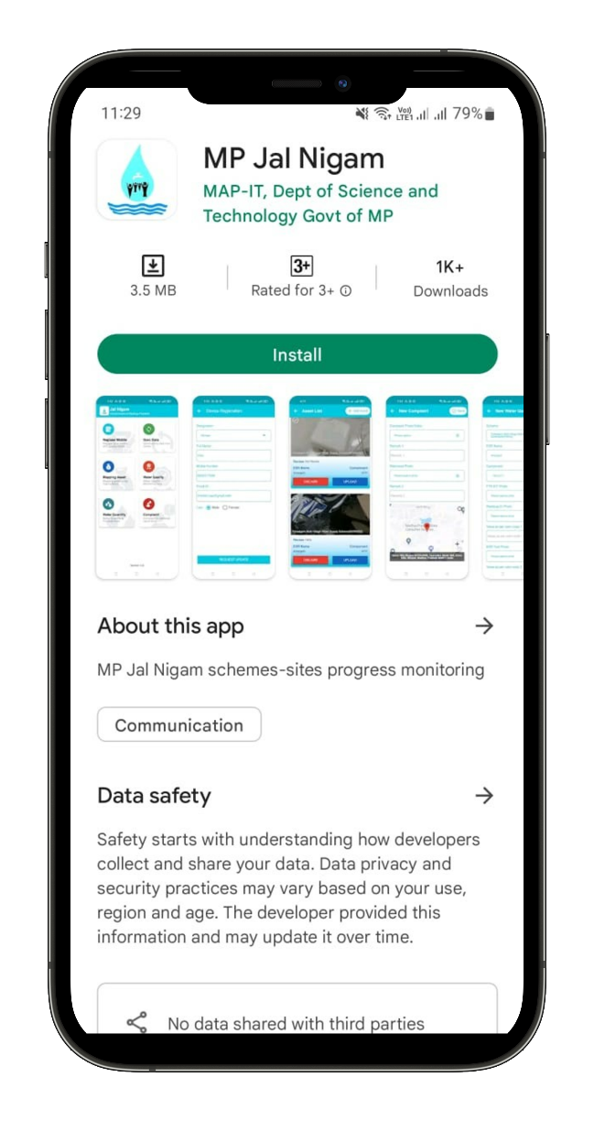
- Open the MP Jal Nigam mobile app.

You are ready to go! Just follow the simple steps.

Device Registration Screen
- After launching application tap on the Registration option and enter the require details in form
- Mobile Number
- Designation
- Full Name
- Email Id
- Password
- Re-Enter Password
- Gender
- Register Mobile Button
- Once User will enter above details and tap on Register Mobile Button then the system will registered the user, save the enter details in the database and redirect to the Home Screen.
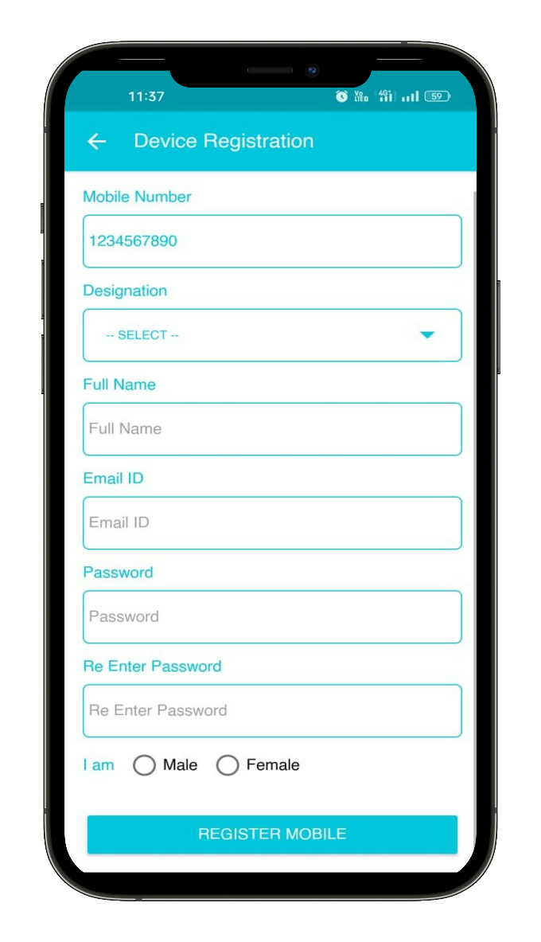

Login Screen
- If User already registered with device and mobile number then user will enter following details
- Registered Mobile Number
- Password
- Next button
- Once User will enter above details and tap on Next Button then the system will redirect to the Home Screen.

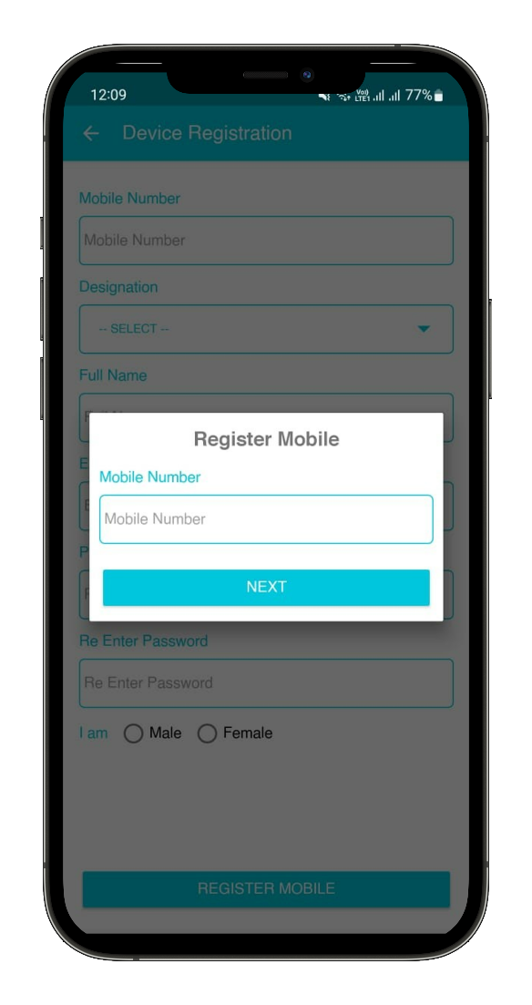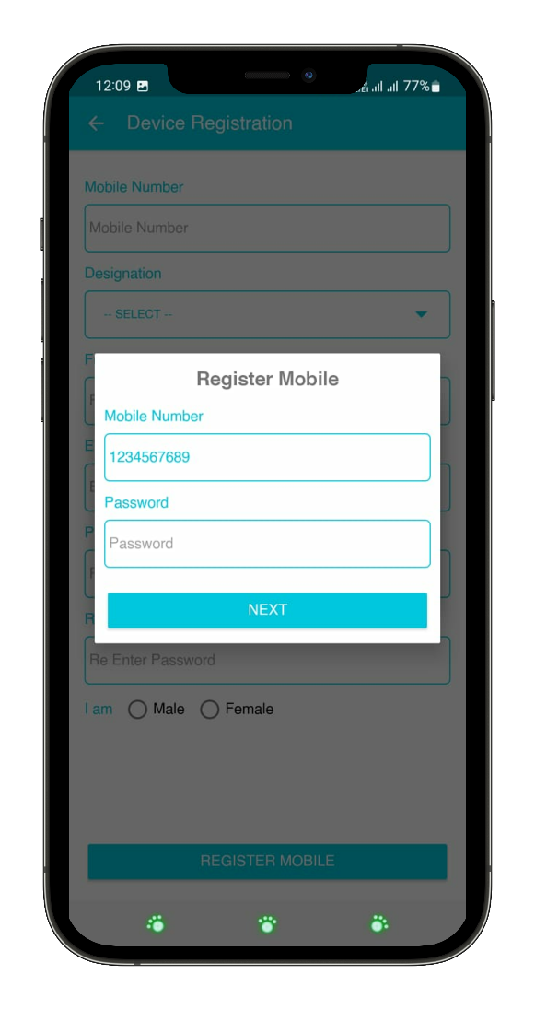

Home Screen
- After successfully registration in the Mobile app, by default user can land on home screen where user can following section-
- Register Mobile
- Sync Data
- Mapping Asset
- Water Quality
- Water Quantity
- Complaint
- Once user will tap on any above options then the system will redirect user to the respective screen
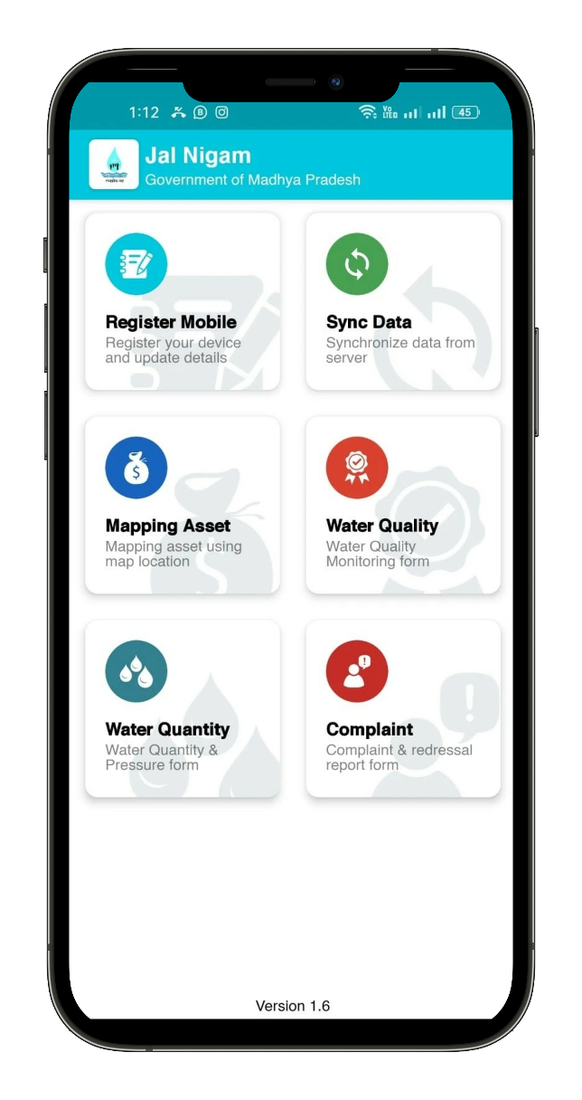

Register Mobile
- User can view their profile details and update it if required. User can view following field-
- Designation
- Full Name
- Mobile Number
- Email Id
- Gender
- Request Update Button
- Once User will enter above details and tap on Request Update Button then the system will update the user details and update details in the database.
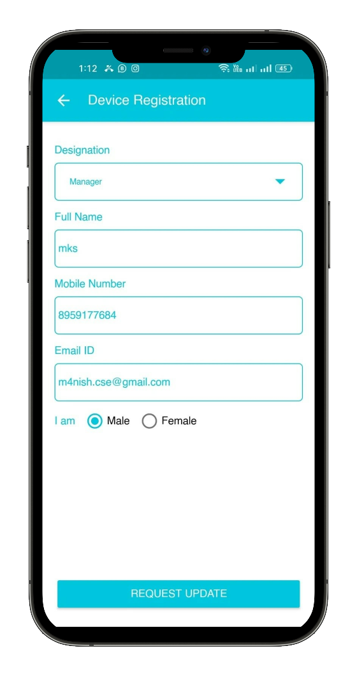

Sync Data
- User need to tab on Sync data section then the system will sync assign component or task and update so user can fill data of assigned schemes.

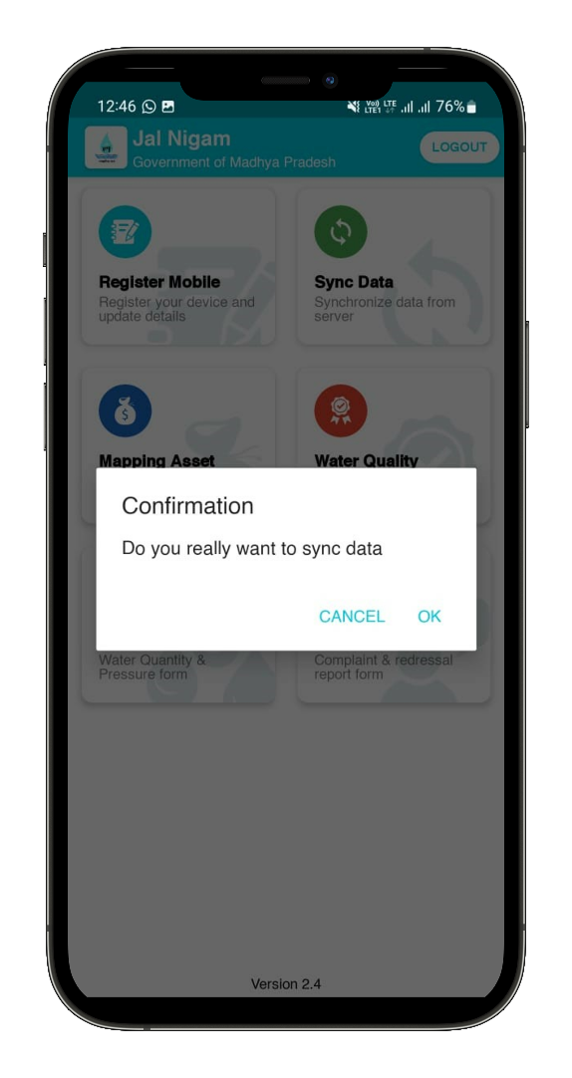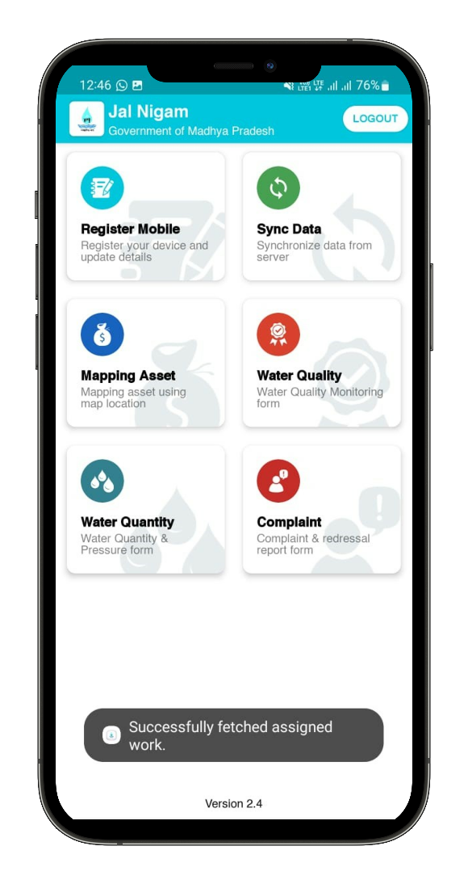

Mapping Asset
- User can fill Asset data by selecting following field
- Scheme (Display assigned schemes– Non Editable)
- Select ESR Location
- Component (Display assigned component – Non Editable)
- Capture or Upload Photo
- Enter Review
- Save button
- Once user will enter any above field and tab on save button then the system will redirect to the Asset list screen.
- User can view list of asset that are added by them with Upload.
- Once user will tap on upload button then the system will submit the data to the concern Authority, state Admin and Admin.

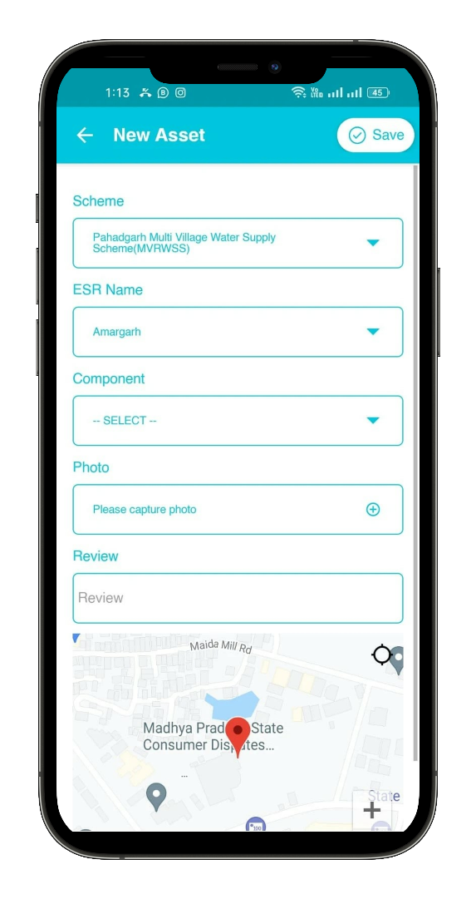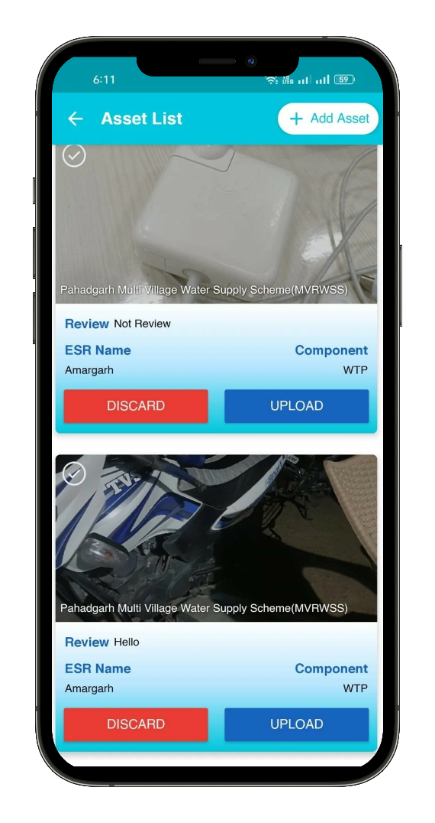

Water Quality
- User can fill water quality details by selecting following field
- Scheme (Display assigned schemes– Non Editable)
- Select ESR Location
- Component (Display assigned component – Non Editable)
- Capture or Upload FTK Kit Photo
- Capture or Upload Residual CI Photo
- Value as per color code 1
- ESR Test Q Photo03
- Value as per color code 2
- Refresh Location
- Save button
- Once user will enter any above field and tab on save button then the system will redirect to the water quality list screen.
- User can view list of water quality that are added by them with Upload.
- Once user will tap on upload button then the system will submit the data to the concern Authority, state Admin and Admin.
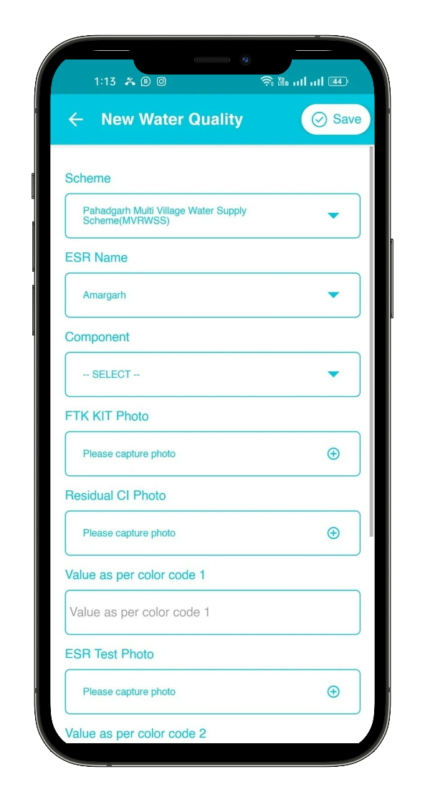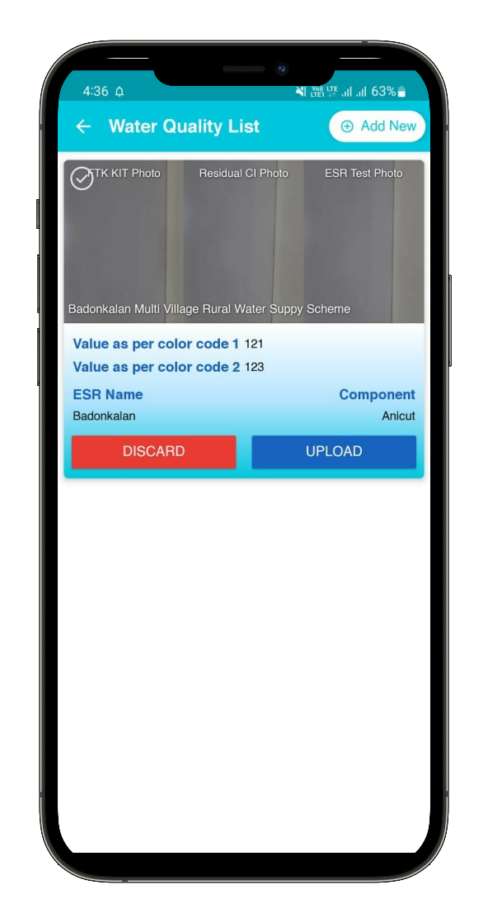

Water Quantity
- User can fill water quantity details by selecting following field
- Scheme (Display assigned schemes– Non Editable)
- Select ESR Location
- Component (Display assigned component – Non Editable)
- Enter Values as per real time measurement
- Capture or Upload Pressure Photo
- Quantity Video
- Refresh Location
- Save button
- Once user will enter any above field and tab on save button then the system will redirect to the water quantity list screen.
- User can view list of water quantity that are added by them with Upload.
- Once user will tap on upload button then the system will submit the data to the concern Authority, state Admin and Admin.

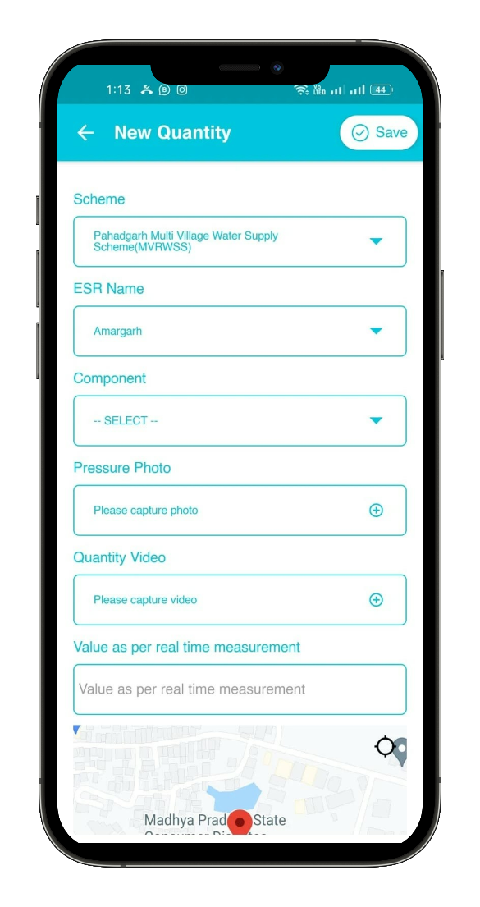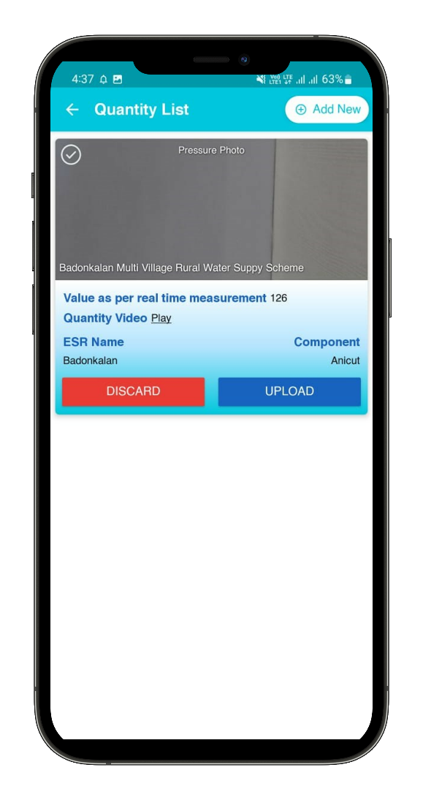

Complaint
- User can fill Complaint details by selecting following field
- Complaint Photo/Video
- Photo
- Video
- Remark 1
- Capture or Upload Redressal Photo
- Remark 2
- Refresh Location
- Save button
- Once user will enter any above field and tab on save button then the system will redirect to the Complaint list screen.
- User can view list of Complaint that are added by them with Upload.
- Once user will tap on upload button then the system will submit the data to the concern Authority, state Admin and Admin.

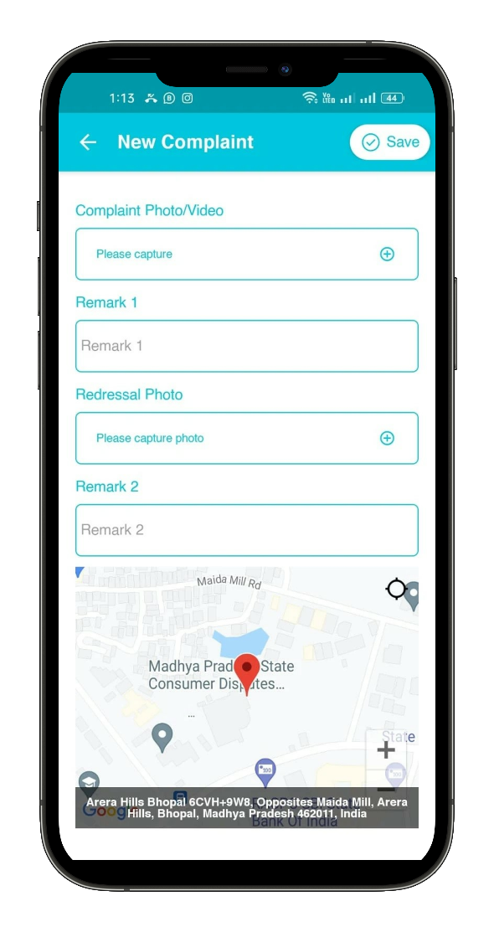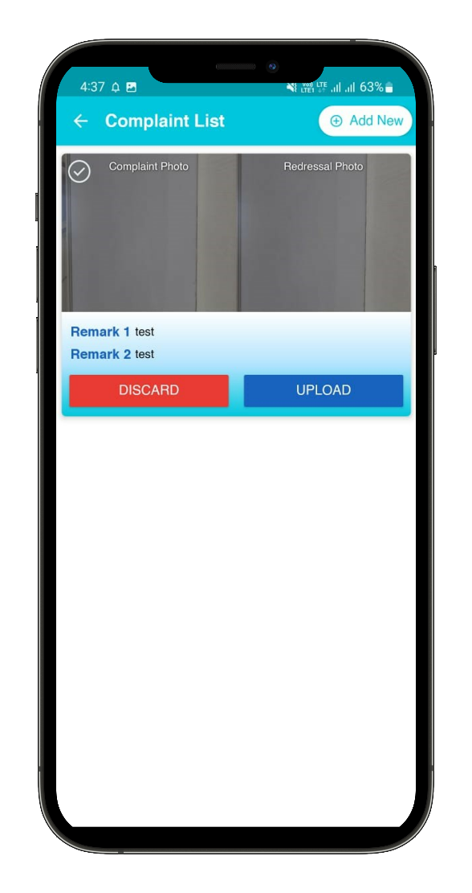

Module…………………… State admin ……………………

State Admin User Login
The web portal can be opened using the URL given below
https://geoportal.mp.gov.in/mpjalnigam/

- State Admin user can access the web application by using the authorized login credentials.
- Click on the Login button
- Enter the desired details on the login page.
- Enter Username.
- Enter Password.
- Click on the Login button.

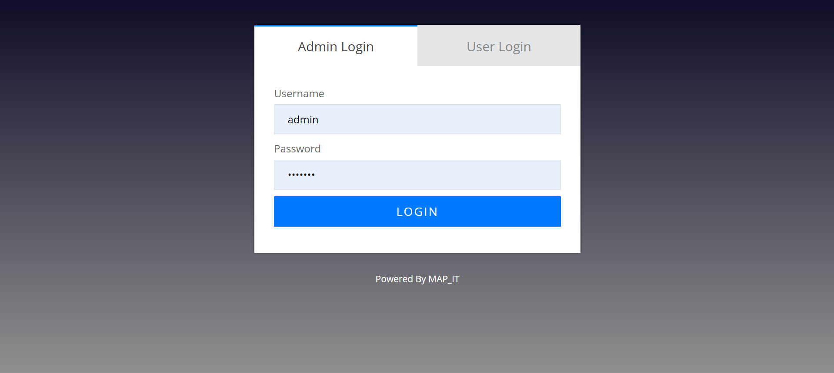

- After successfully login, State Admin user will land on User Management page. User can view following menu in header
- User Management
- Data Visualization
- Water Quality & Monitoring
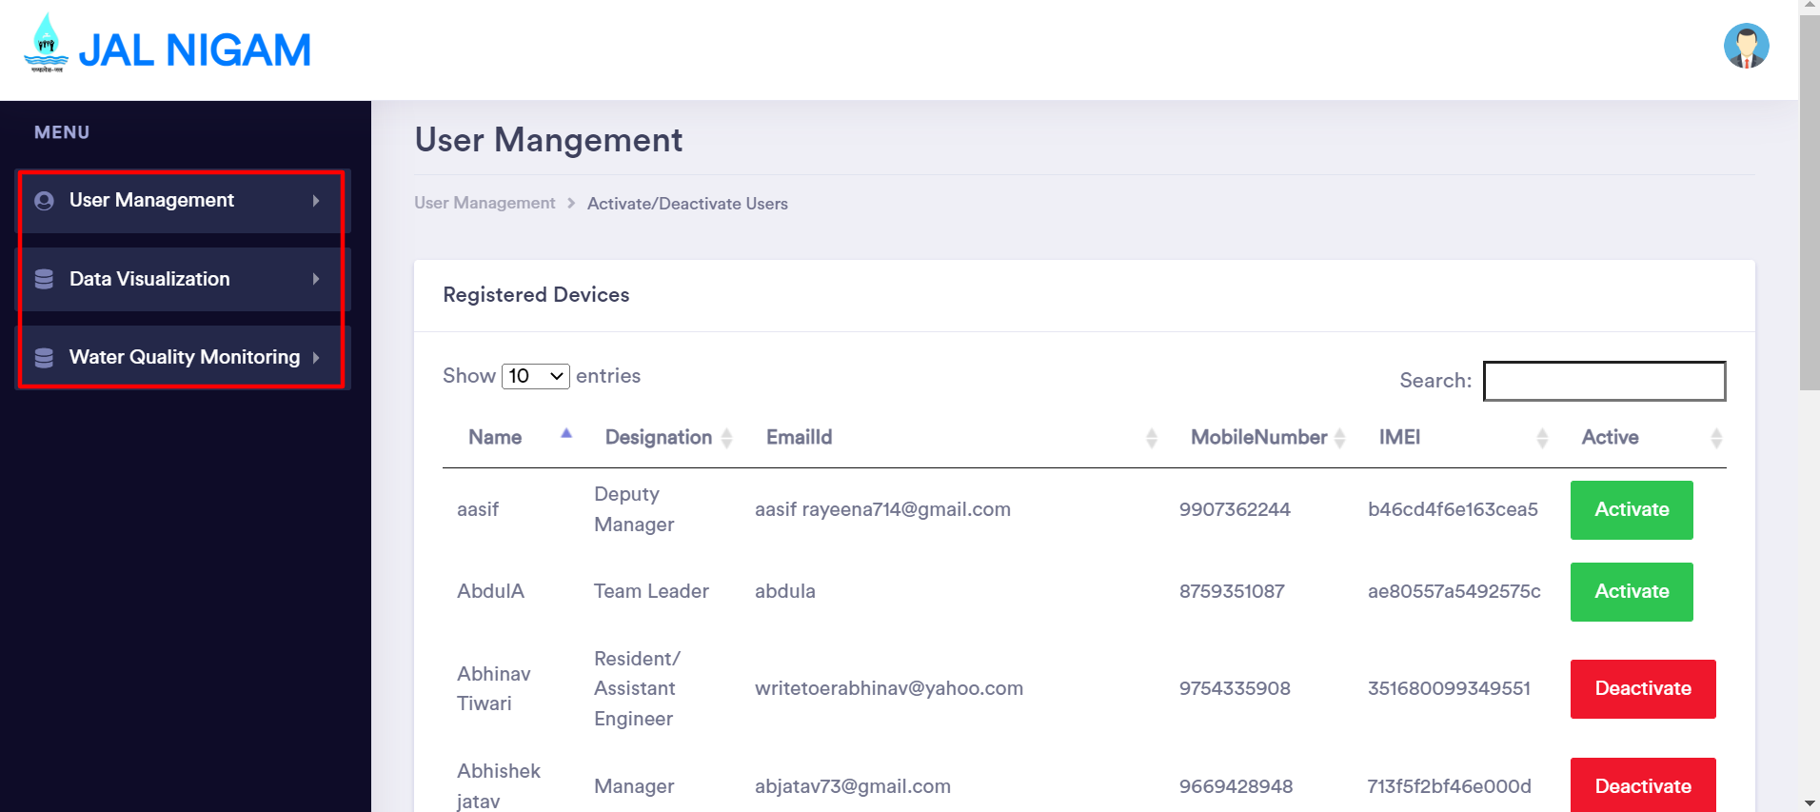

User Management
- State Admin user will click on user Management then State Admin user can view following options
- Activate/ Deactivate Users
- Pending For Approval
- Assign Work
- Once State Admin user will click on any above options then the system will redirect user to the respective page

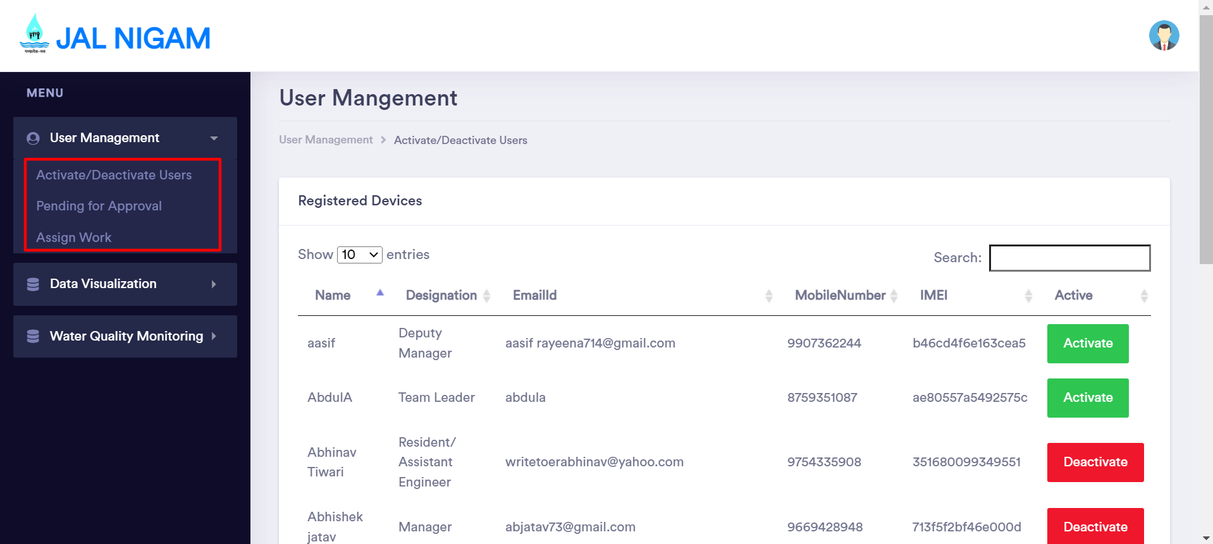

Activate/ Deactivate Users
- If State Admin user will select Activate/ Deactivate Users then the system will redirect user to the respective page.
- State Admin user can view list of registered mobile user that are self-registered into Mobile app, State Admin user can view following details
- Name
- Designation
- Email Id
- Mobile Number
- IMEI
- Status of User
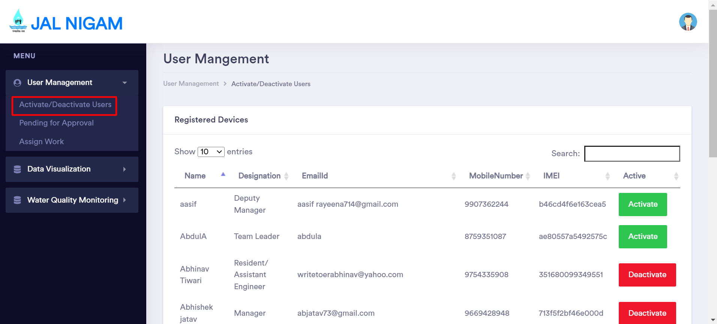

- State Admin user will receive Mobile user request to Activate and Deactivate. State Admin user have rights to Activate/Deactivate any user.

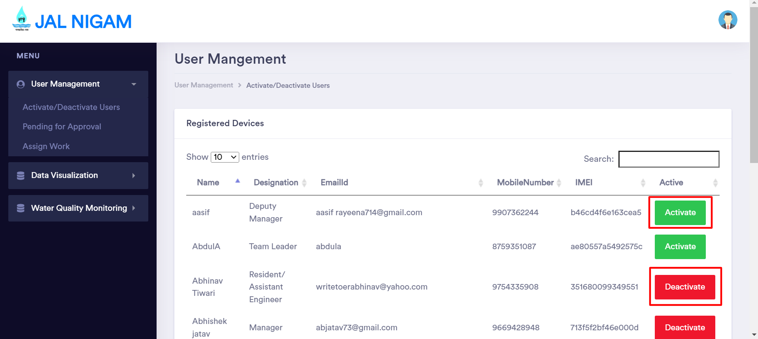

Pending For Approval
- State Admin user can view list of registered mobile user that are pending for approval. State Admin user can view following details
- Name
- Designation
- Email Id
- Mobile Number
- IMEI
- Action
- Approve/ Delete link
- State Admin user will approve or Delete any user that are available in the list.
- State Admin user can search any user by enter keyword in the search box.
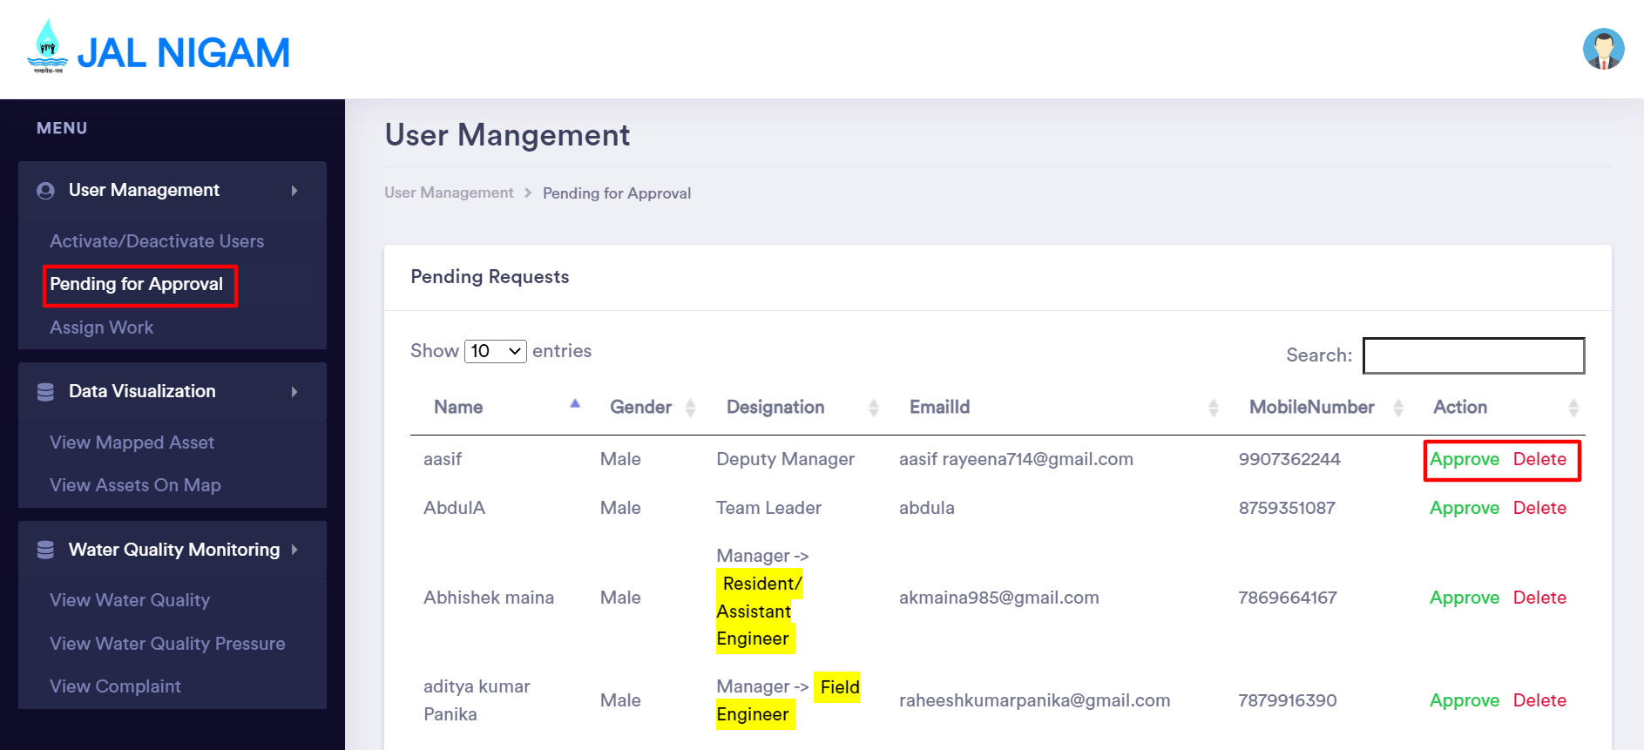

Assign Work
- State Admin user will assign work for any user that are registered, State Admin user will assign work by selecting following field
- Select User
- Select Scheme
- Select ESR Location
- Assign and Reset button
- Once State Admin user will click on Assign button then the system will assign that selected scheme to the selected user.
- State Admin user can view selected user work that already assign the work.

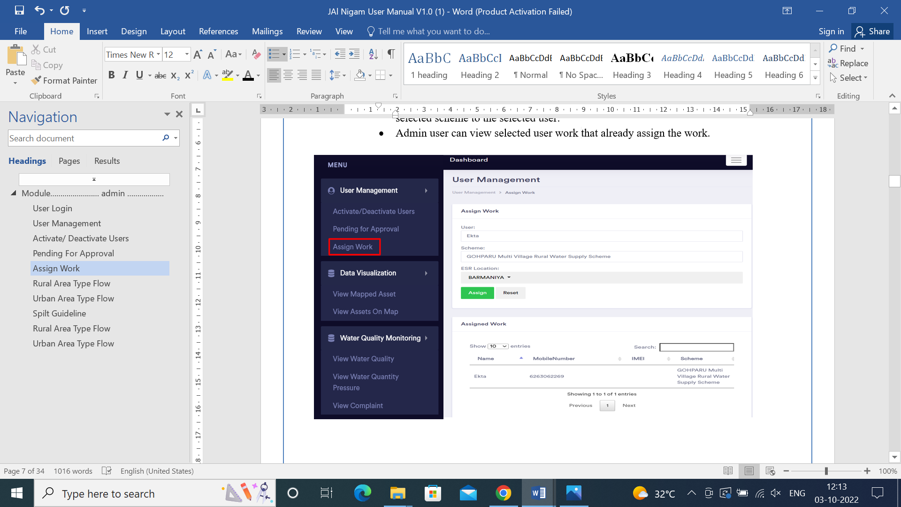

Data Visualization
- State Admin user will click on Data Visualization then State Admin user can view following options
- View Mapped Asset
- View Asset on Map
- Once State Admin user will click on any above options then the system will redirect user to the respective page
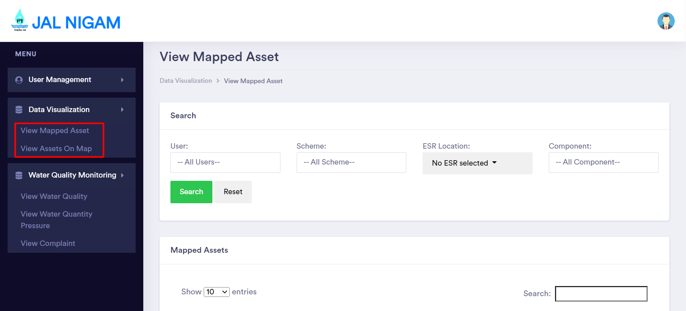

View Mapped Asset
- If Admin user will select view Mapped Asset then the system will redirect user to the respective page.
- State Admin user can search data by selecting any field in below available field
- Select User
- Select Scheme
- Select ESR Location
- Select Component
- Search and Reset button
- Once State Admin user will select any above field and click on search button then the system will display all the list of Asset data of selected user that selected user added.
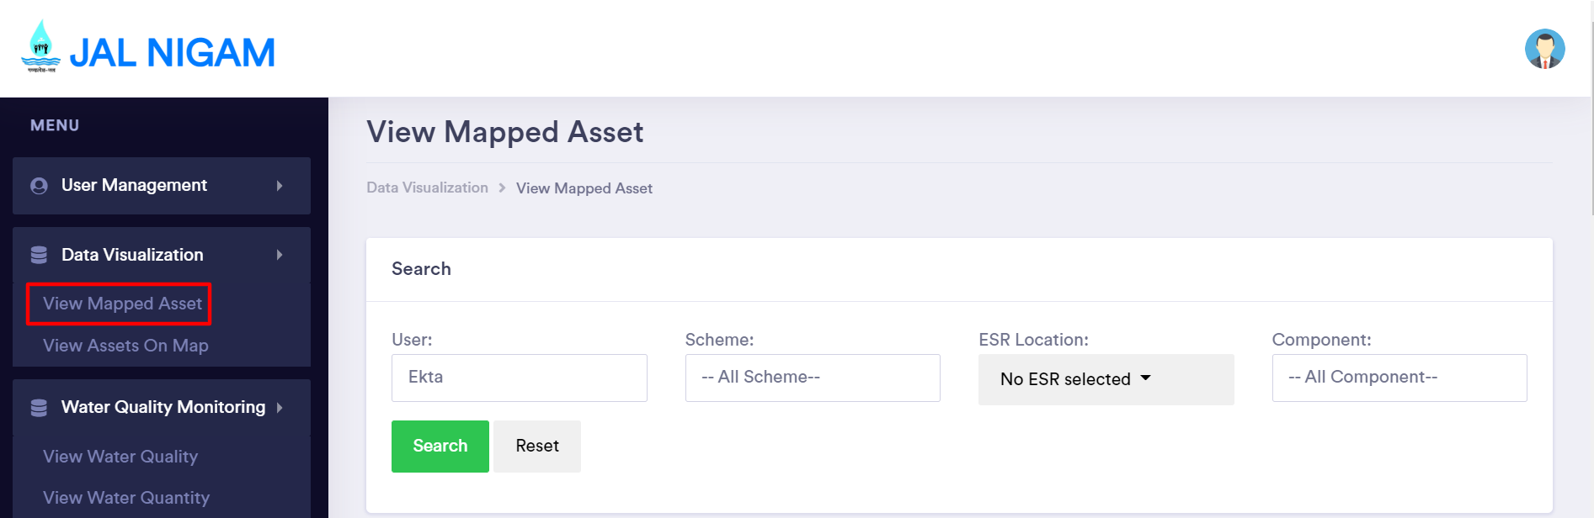

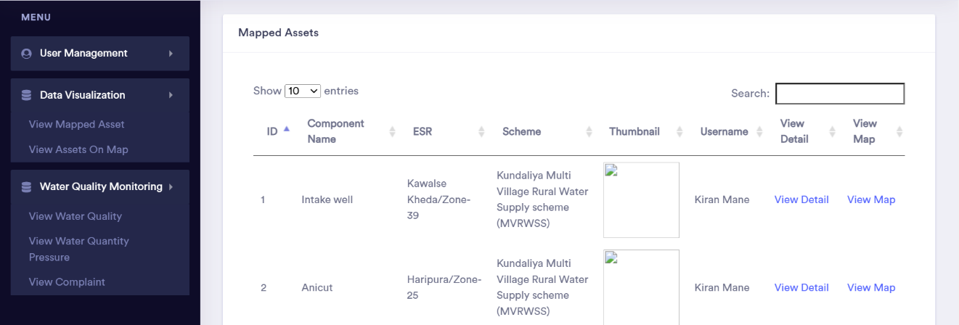

View Asset on Map
- If State Admin user will select view Asset on map then the system will redirect user to the respective page.
- State Admin user can search data by selecting any field in below available field
- Select User
- Select Scheme
- Select ESR Location
- Select Component
- Search and Reset button
- Once State Admin user will select any above field and click on search button then the system will display all the list of Asset data of selected user on map that selected user added by Mobile app.
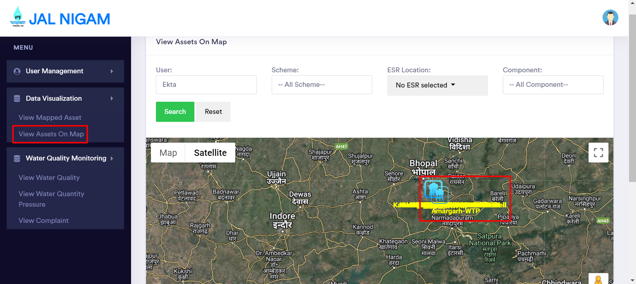

Thank you

